Report on a data visualization dashboard for a study on immunization and vaccination for Medical Research Council Research Uganda
Synonyms
GCP: Good Clinical Practice
GDPR: General Data Protection Regulations

Introduction
In this section, we provide an overview of the purpose and objectives of the data visualization dashboard for the I-VAC project. Data on vaccination studies conducted as part of the Immunodulation and vaccines program (I-VAC) are explicitly included in the dashboard. Data visualization, according to Sharvari (2021), uses maps, graphs, and data analytics to help users make informed decisions. The dashboard design for I-VAC is intended to offer a thorough and intuitive user interface for displaying important patterns and insights from the research participants' data.

Purpose
According to Renato et al. (2018), a picture really is worth a thousand words when seeking to understand and draw conclusions from data. The dashboard's goal is to provide principle investigators and other stakeholders with an intuitive and thorough user interface that enables them to monitor and assess participant enrolling and follow-up data.
Users can examine and comprehend the data, spot trends, and acquire insights to assist data-driven decision-making using the dashboard.

Objectives
The following is a list of the objectives that guided the creation and design of the I-VAC dashboard
- A responsive dashboard that is interactive and has clear graphics.
- Incorporate key performance indicators (KPIs) important to the principal investigators and other users.
- Give users the ability to filter and drill down into specific information subsets.
- Display the data in an aesthetically appropriate and visually appealing way.

Methodology
This section outlines the methodology employed to design the I-VAC data visualization dashboard.

Data Collection and Preparation
Data from the I-VAC research project was taken from the main data collecting system, REDCap, in order to fulfill the dashboard's purpose. Data was limited to 10 variables for this study's purposes and exported to an excel file, which is compatible with Tableau.
Participant IDs were deleted from the data during data preprocessing in accordance with GDPR and Ugandan data protection law (GDPR, 2016) (The Republic of Uganda, 2019). To ensure consistency and correctness, the data was then cleaned i.e. duplicate data were deleted and transformed accordingly (Sven, 2020).

User Requirements Analysis
The following techniques were utilized to gather user requirements and analyze them in order to improve the functionality of our dashboard:
  - Domain specific requirements i.e. clinical research standards (GCP, GDPR)
  - User experience in data management and reporting
  - Interviewing users

Dashboard Design
Based on the user requirements, we designed the dashboard layout and selected appropriate data visualization techniques including:
  - Map visualization to show distribution of participant in the study sites. Lewis (2019) asserts that maps also offer an eye-catching visual aesthetic that increases the user attractiveness of the dashboard.
  - Bar charts to display distribution in categorical data, such as sex
  - Boxplots to show the distribution of continuous data, such as age, sex groups, and location
  - Line graphs to show trends in participants' follow-up over the course of the study.
  - Data on the enrolment and retention rates of study participants.

Dashboard Development
The dashboard was developed using tableau software, a visual analytics platform and is widely used by the business intelligence industry (Tableau, 2023). In order to make the dashboard interactive and visually appealing, the following was done.

Defined the audience
    - Principle investigator. He/she oversees study procedures, including enrolling and obtaining consent from participants.
    - Research assistants. They collect and submit data on research participants.

Data extraction
    - Excel files are one of the many data sources that Tableau supports. Before importing the primary dataset into Tableau, ten variables were found and extracted from it in excel format. See appendix A
    - The variables chosen indicate information needed to achieve the goals of the I-VAC dashboard. The following information is what was extracted.
      - demographic information (age, sex)
      - Status of participant enrollment (eligibility, consent)
      - visit status (visit period, visit date),
      - study status (study completion status, lost to follow-up)
      - geographical information (site location)

Data reprocessing:
    - Data cleaning i.e. deleted duplicates
    - Transformation i.e. appending country codes

Created Worksheets and Visualizations:
    - Created worksheets for the following
      - Sites map
      - Follow-up rate
      - Demographics data
      - Age distribution
      - Data statistics

Choose appropriate chart types
  - Research sites' map
  - Bar charts that display distribution in categorical data, such as gender. Marc and Nils (2014) suggest using bar charts to represent counts by length since they are a very accurate visual encoding.
  - Boxplots showing distribution in age, grouped by sex, site. Boxplots are useful in comparing different distribution groups (Mike ,2021).
  - Line graphs to display patterns in participant follow-up Line charts are commonly used to visualize a series of data samples (Paul & Ghulam, 2020).

Incorporated Worksheets into a Dashboard:
        - Containers were used to organize and control the layout of the charts from the worksheets. Enrolment data, or summary statistics, are available in the top left corner for quick visualization.

The dashboard's interactivity:
  - filters, parameters, and actions have been added enable users to explore the data and change visualizations dynamically.

User Testing
To ensure the usability and effectiveness of the dashboard, several rounds of user testing and feedback collection were conducted. Necessary adjustments and improvements were made based on the findings.

Dashboard Features
This section highlights the key features of the data visualization dashboard.
- Overview Summary
The dashboard provides an executive summary with key performance indicators and high-level insights, allowing users to grasp the main trends at a glance.
- Interactive Visualizations
The core of the dashboard consists of interactive visualizations, including line charts, bar graphs, pie charts, and geographic maps. Users can interact with these visualizations by applying filters, selecting data points, and zooming in/out.
- Data Filters and Drill-Down
Users can filter the data based on various criteria, such as time periods, geographical regions, data categories, and more. Additionally, drill-down capabilities allow users to explore specific data subsets in detail. See appendix C
- Responsive Design
The dashboard is optimized for various screen sizes, including desktops, tablets, and smartphones, to accommodate the preferences and needs of all users.

Limitation
Limited data availability due to data sharing procedures under the research program. We were only limited to using ten variables and a subset of records for the I-VAC dashboard.
The time for refining the dashboard design was limited by the trial version for the tableau desktop software. All the design and testing had to be done within the 14 days’ trail period.

Conclusion
The data visualization dashboard design presented in this report aims to provide a powerful tool for exploring and understanding complex data. By incorporating interactive visualizations, user-friendly features, the dashboard empowers stakeholders to make informed decisions.

Recommendation.
Moving forward, continuous feedback and improvements will be crucial to enhancing the dashboard's functionality and effectiveness.
Principle investigators and project leaders should try an explore using tableau as a data visualization tool for the study. More data should be made available for more functional design and implementation in other project activities.

Appendix:
- Appendix A

Variable Name | Question
participantID | Participant identification number
sex | Sex of participant
age | Participant's age
consented | Participant's consent status
eligible | Participant's eligibility status
Time_Point | Visit number
visit_date | Date of the visit/follow-up period
completed_study | Participant's study completion status
location | Study site
country | country
drop_out_reason | Lost to follow-up reason
entered_by | Initials of the person entering data

list of variables which were considered for our I-VAC dashboard
- Appendix B I-VAC Dashboard layout

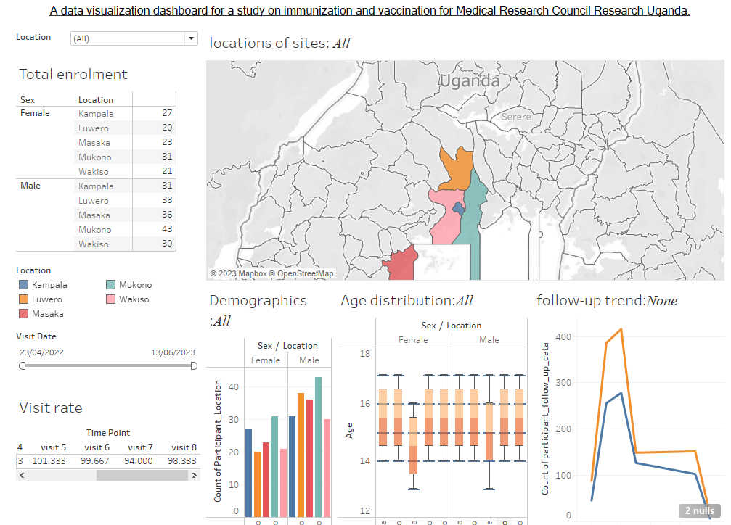

Appendix C
Users can filter the data based on various criteria, such as visit dates, geographical sites or location

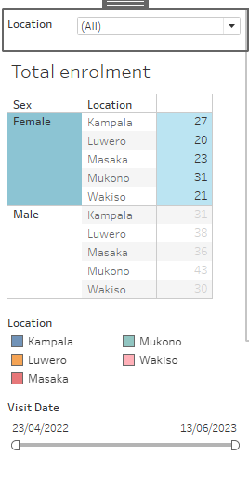

References:
Santosh. S. (2021) A Comprehensive Guide On Data Visualization In Python, Anlytics Vidhya. Available from: https://www.analyticsvidhya.com/blog/2021/10/a-comprehensive-guide-on-data-visualization-in-python/ [Accessed on 12 July 2023]
Renato, T., Marias, M., Catarina, R., David, G. (2018) Data visualization techniques for real-time information — A custom and dynamic dashboard for analyzing surveys' results. Available from: https://ieeexplore.ieee.org/abstract/document/8398641 [Accessed on 15 July 2023]
European Union General Data Protection Regulation (GDPR). (2016). Available from: https://eur-lex.europa.eu/legal-content/EN/TXT/?qid=1532348683434&uri=CELEX:02016R0679-20160504
The Republic of Uganda. (2019). The Data Protection and Privacy Act, 2019. Available from: https://ict.go.ug/wp-content/uploads/2019/03/Data-Protection-and-Privacy-Act-2019.pdf [Accessed 10 July 2023]
Sven, B. (2020). Data Strategy: Good Data vs. Bad Data. Towards Data Science from https://www.datasciencecentral.com/profiles/blogs/no-data-is-better-than-bad-data
Tableau (2023). Tableau Desktop. Available from https://www.tableau.com/why-tableau/what-is-tableau
Mike, Y. (2021) A Complete Guide to Box Plots. CHARTIO. Available from: https://chartio.com/learn/charts/box-plot-complete-guide/ [Accessed on 27 June 2023]
Marc, S.,Nils,G. (2014) Bar charts and box plots: creating a simple yet effective plot requires an understanding of data and tasks. NATURE METHODS. Available from https://go.gale.com/ps/i.do?id=GALE%7CA361242512&sid=googleScholar&v=2.1&it=r&linkaccess=abs&issn=15487091&p=HRCA&sw=w&userGroupName=anon%7Ed539b7cd&aty=open+web+entry
[Accessed 20 Jul 2023]
Paul, R, Ghulam, J. (2020) LineSmooth: An Analytical Framework for Evaluating the Effectiveness of Smoothing Techniques on Line Charts. IEEE Transactions on Visualization and Computer Graphics, vol. 27, no. 2
Lewis, C. (2019) Top 10 Map Types in Data Visualization. Toward Data Science. Available from: https://towardsdatascience.com/top-10-map-types-in-data-visualization-b3a80898ea70
[Accessed on 20 July 2023]

